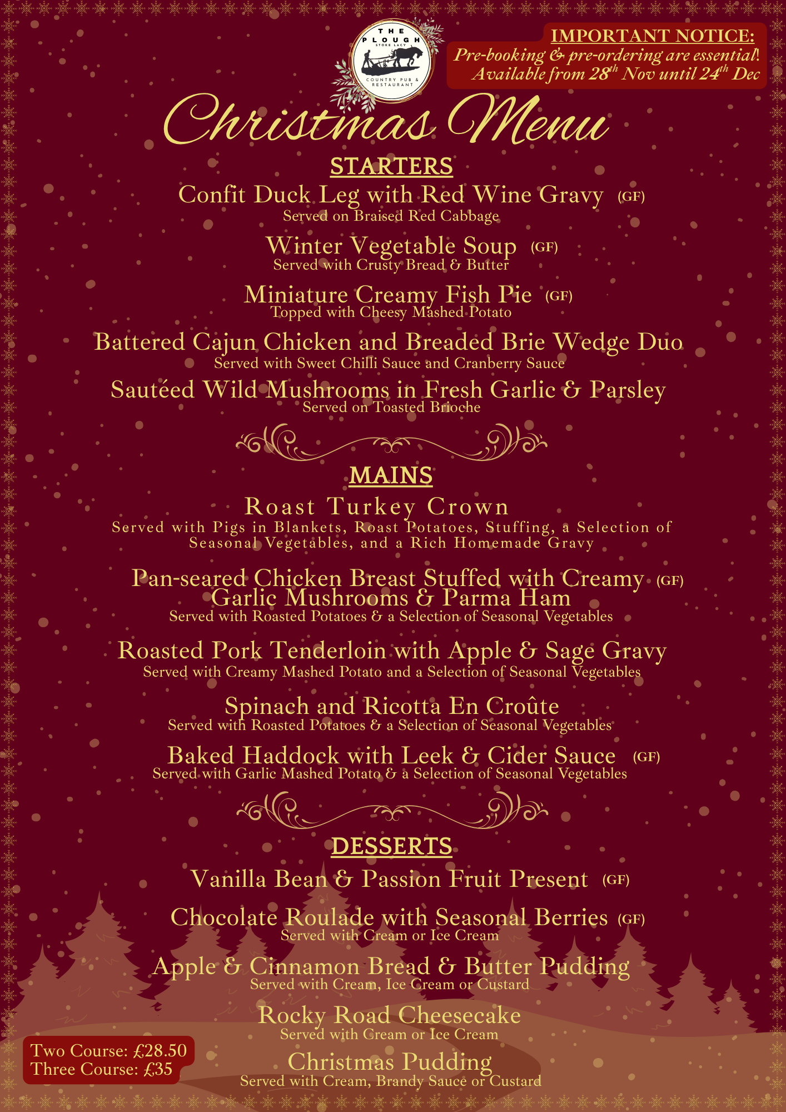

Order Form
*Please let us know about any dietary requirements or allergies*

Confit Duck Leg with Red Wine Gravy Served on Red Cabbage (GF)
Winter Vegetable Soup (GF Without Bread)
Miniature Creamy Fish Pie Topped with Cheesy Mashed Potato (GF)
Battered Cajun Chicken and Breaded Brie Wedge Duo
Sautéed Wild Mushrooms in Fresh Garlic & Parsley on Brioche Bread
STARTERS

Roast Turkey Crown with all the Trimmings
Pan-seared Chicken Breast Stuffed with Creamy Garlic Mushrooms & Parma Ham (GF) served with roast potatoes & vegetables
Roasted Pork Tenderloin with Apple & Sage Gravy served with mashed potato & vegetables
Spinach and Ricotta En Croûte served with roast potatoes & vegetables
Baked Haddock with Leek & Cider Sauce (GF) served with garlic mashed potato & vegetables
MAINS

Vanilla Bean & Passion Fruit Present (GF)
Chocolate Roulade with Seasonal Berries (GF)
served with cream or ice cream
Apple & Cinnamon Bread & Butter Pudding
served with custard, cream or ice cream
Rocky Road Cheesecake served with cream or ice cream
Christmas Pudding served with custard, brandy sauce or cream
DESSERTS

Please send this to us at least 4 days before you have your meal.
Email us at: ploughinnstokelacy@gmail.com

Merry Christmas from Simon, Nardia & their team at The Plough, Stoke Lacy!

